Homework Menu – Autumn 1

Draw a poster advertising the Titanic when it was a brand new ship, persuading people to travel on it. | Write a menu for a meal for a first class passenger, and a menu for a third class passenger on the Titanic.  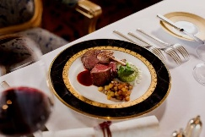 | Research to find the lengths of cruise liners today. Make a poster showing the different cruise liners compared to the size of the Titanic.
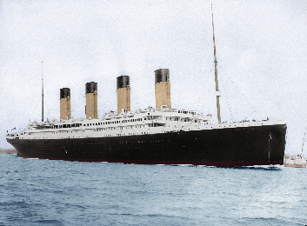  Research and create a fact file about the Titanic. | Explore sinking and floating. Use materials around the house to invent something that will allow a £1 coin to float. Keep a record of your investigation. Make sure you check with your adults before using any materials. | 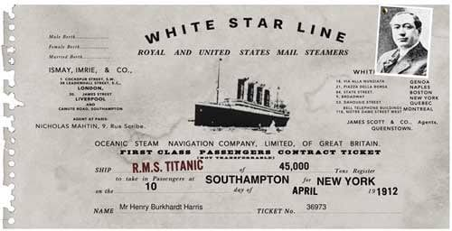  Design a ticket for the Titanic.
Draw a picture of the Titanic, or make a model. You could use recyclable materials. | 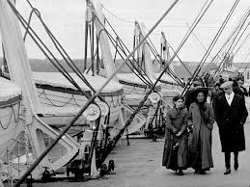  Write a story, diary entry or poem about being a passenger on board Titanic’s voyage. | Design a coin to commemorate the 115th anniversary of the sinking of the Titanic next year.
This half term our topic is ‘The Titanic’. Complete 3 of the homework activities and bring them into school by Wednesday 21st October. I’m looking forward to seeing them.
Reading: Please make sure children are reading aloud to an adult every day. Children also have logins for Read Theory and can access this from home.
Spelling: Children have access to spelling shed for spelling practice.
Weekly homework: We will be focusing our weekly homework on times tables in preparation for the Times Tables check in summer term. Weekly practice is important. Times Tables Rockstars will be set for our focus Times Tables each week.

