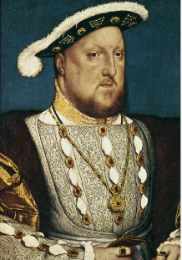
Autumn 1 – The Tudors
Year 5

English – The Executioner’s Daughter
- Children will identify the audience for and purpose of writing and select the appropriate form and use other similar writing as models for their own diary entry.
- Select appropriate grammar and vocabulary to enhance meaning.
- Evaluate and edit by assessing the effectiveness of their own and others writing.
- Use a range of devices to build cohesion within and across paragraphs.
Maths – Decimal fractions
- Identify fractions as part of a whole and represent these using concrete and pictorial resources.
- Count in tenths, write fractions as decimals, order, add and multiply fractions.
- Calculate with decimals using their knowledge of place value and column addition/subtraction.
- Round numbers with decimal places.
- Solve real world problems with fractions and decimals.
Science – Fossils, geological time and classification (What is evolution and how do we know it happened?)
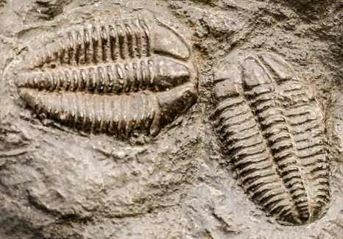
- Children will learn about how old the Earth is, when life was discovered and the process of evolution.
- Learn about fossil formation and how fossils help us learn about the history of the Earth.
- Classification of plants and animals.
History – How did the Tudors impact Hampshire?
- Children will learn about significant individuals within the Tudor period, where the Tudor period falls in terms of chronology with other areas studied.
- Children will learn key events and dates within the Tudor period and what life was like during Tudor times.
- Visit the Mary Rose Museum and explore how the Tudors impacted Hampshire.

Art – Hans Holbein
- Learn about Hans Holbein and his work, comment on his work using visual language identifying what they like and dislike.
- Investigate the proportions of the human face and practise sketching the different features of a portrait.
- Learn how to mix colours to create the desired skin tones and features such as hair.
- Add sculpture to a portrait in the style of Hans Holbein using mixed media.
PSHE – Respectful Relationships
- Children will learn how to respond respectfully to a wide range of people; recognising prejudice and discrimination.
RE – Belonging (in Islam)
- Children will learn about the concept of belonging and how this can be applied to their own and others’ lives.
- What it means to belong and why this is important to Muslims.
Computing – Systems and Searching
- Children will develop their understanding of computer systems and how information is transferred between systems and devices (small scale and large-scale systems).
- Discover how information is found on the world wide web through investigating search engines.
French – Monster Pets
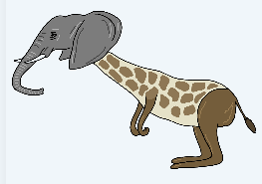
- Notice cognates and near cognates in the text, recognise some previously known words.
- Use a dictionary to research the meaning of relevant vocabulary.
- Produce a short, structured paragraph using a range of familiar structures, with some manipulation of language and use of a word bank for support.
Music – A Bao A Qu-Fantastical Beasts
- Create, develop and perform fantastical beast compositions as a class and in a small group.
- Understand, read and notate pitch using traditional staff notation.
- Create, develop and perform a fantastic beast melodic palindrome.
PE – Ball Skills, Reaction and Response – Tag Rugby
- Develop and apply ball skills in modified games to improve throwing and catching skills combined with reaction and response skills to enable greater success when under pressure
- Prepare for traditional invasion games, particularly ball sports that involve creating and finding space and require keeping possession and responding to set play instructions. Learn about attacking and defending strategies to help make effective decisions
- Develop the personal skills to persevere and cope well when finding things challenging, and to embrace that both regular, focused practice and failure are key aspects of learning

