 |  | Autumn 1 | Autumn 2 |  |  |  | Spring 1 | Spring 2 |  |  |  | Summer 1 | Summer 2
Year 5 Curriculum overview 2023 24 |  | Tudors  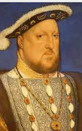 | The Environment  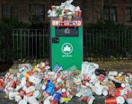 |  |  |  | Space  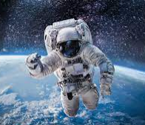 | Crime and Punishment   |  |  |  | Ivory coast  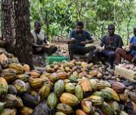 | Ancient Egypt  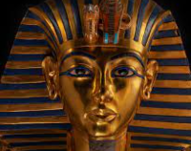
TRIPS |  | The Mary Rose Museum/ Hampton Court |  |  |  | INTEC- Planetarium |  |  |  |  |  | Swimming | Haslemere Museum
English  Writing journey |  | Text Driver:  ‘The Secret Diary of Thomas Snoop, Tudor Boy Spy -  Philip Ardagh  The Queen’s Token -Pamela Oldfield | Text Driver:  ‘Kensuke’s Kingdom’ – Michael Morpurgo  The Whale- Ethan Murrow |  |  |  | Text Driver:  The darkest Dark  ‘Tim Peake – Ask an astronaut’ – Tim Peake  Space poetry | Text Driver:  ‘The Summer I robbed a bank’ David O’Doherty  The Highway man |  |  |  | Text Driver:  The Paperbag Prince-  Colin Thompson  Nelson Mandela- long walk to freedom- Chris Van Wyk | Text Driver:  ‘Mystery of the Egyptian mummy’ – Scott Peters  The Awesome Egyptians-  Terry Deary
Reading |  | 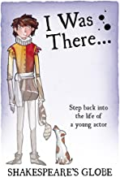  Focus domains:  Respond and explain  Inference  Summarise  Focus text:  Thomas Snoop- Tudor Boy spy  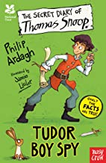  Focus domains:  Clarify  Select and retrieve | 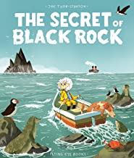  Focus domains:  Themes and conventions  Select and retrieve  Focus text:  Kensuke’s Kingdom  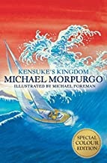  Focus domains:  Language for effect  Themes and conventions |  |  |  | 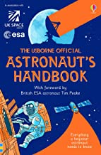  Focus domains:  Themes and conventions  Select and retrieve  Focus text:  Hidden figures  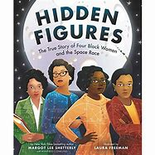  Focus domains:  Summarise  Respond and explain | Horrible History- Cruel crime and painful punishment  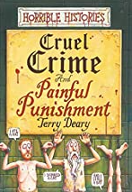  Focus domains:  Inference  Language for effect  Focus text:  Boy in the Girl’s bathroom  Focus domains:  Clarify  Summarise |  |  |  |   Focus domains:  Themes and conventions  Select and retrieve  Focus text:  Stormbreaker  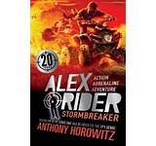  Focus domains:  Language for effect | So you think you’ve got it bad Ancient Egypt  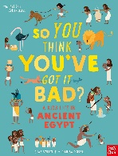  Focus domains:  Clarify  Respond and explain  Focus text:  Mystery of the Egyptian scroll  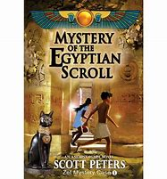  Focus domains:  Summarise  Respond and explain
Science  (see LTP when to teach) |  | Fossils, geological time space and gravity making new substances Forces that oppose motion circulation  and classification  4 sessions 8 sessions 8 sessions 8 sessions 7 sessions
Geography |  |  | The Environment  What is so special about our oceans? |  |  |  | The Earth  Is every country equal? |  |  |  |  | The Ivory Coast  What is unique about chocolate? | Egypt / Africa - Maps
History |  | Local History Study -  How did the Tudors impact Hampshire? |  |  |  |  |  | British Study that extends beyond 1066 Theme: ‘Crime and Punishment’  How have approaches to crime and punishment changed through the ages in Britain? |  |  |  |  | Overview of the earliest civilizations Egypt  What was life like in Ancient Egypt compared to modern times?
RE  Living Difference |  | Belonging  Shahada and salat | Interpretation  Christmas - the 2 birth narratives |  |  |  | Stewardship  Creation  (Christianity & Islam) | Symbol  Eucharist or Sacrifice |  |  |  | Sacred place  Places of Worship  (Christianity & Islam) | Umma  Hajj and Sakat
PE  Indoor |  | Fitness: Interval and flexibility training | Dance |  |  |  | Gymnastics: bridges | Fitness: Fartlek and weight training |  |  |  | Swimming | Gymnastics: flight
PE  Outdoor/ coach |  | Invasion Games: Netball  Games coach | Invasion Games: Hockey  Games coach |  |  |  | Net and Wall Games: Tennis | Net and Wall Games: Badminton  Games coach |  |  |  | Striking and Fielding Games: Cricket and Rounders  Games coach | Multi-Skills and Athletics
Art |  | Hans Holbein  Drawing Painting Sculpture | Katsushika Hokusai  Drawing Painting textiles |  |  |  | Peter Thorpe  Drawing Painting sculpture | Charles Keeping  Drawing Painting |  |  |  | Ephrem Kouakou  Drawing Painting  Textile | The British Museum  Kate Malone  Drawing Painting sculpture
Computing  Teach Computing |  | Systems and searching |  |  | Creating media- video production |  | Programming A – Selection in physical computing | Data and information - flat-file database |  |  |  | Vector drawings | Programming B – Selection in quizzes
DT  Kapow |  | Electrical Systems: Doodlers |  |  |  |  | Mechanical Systems: Pop up book |  |  |  |  | Food: What could be healthier?
Music |  | Dimensions Focus: pitch & structure | Dimensions Focus: pitch & duration |  |  |  | Dimensions Focus: texture & timbre | Dimensions Focus: pitch & structure |  |  | Dimensions Focus: duration & structure |  |  | Focus: dynamics, tempo & structure
PSHE /RSE  Overview |  | RESPECT | SELF REGULATION |  |  |  | FOCUS | BOUNDARIES |  |  |  | INDEPENDENCE | RESILIENCE
MFL  French  Kapow | French Monster pets |  |  |  | Shopping in France |  | Space exploration - in French |  | French speaking world | Verbs in a week |  |  |  |  | Meet my French family

