Year 3 Wider Curriculum | Stone Age and Iron Age  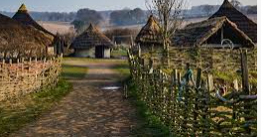 |  | Waterlooville  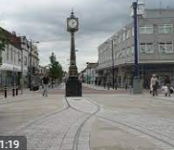 |  | The UK  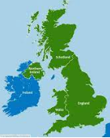 |  | Roald Dahl  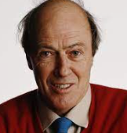 |  | Romans  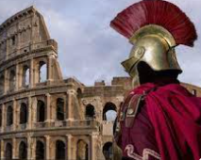 |  | Zoos- animals  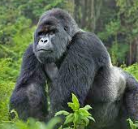
TRIPS | Butser Ancient farm |  | Waterlooville |  | Library/ swimming |  | Chocolate workshop |  | Fishbourne Roman Palace |  | Marwell Zoo
English  Writing journey | Text Driver:  ‘Stone age boy’ – Satoshi Kitamura  ‘How to wash a woolly mammoth’ – Michelle Robinson |  | Text Driver:  Journey’  Aaron Becker  ‘Window’ – Jeannie Baker |  | Text Driver:  ‘The Queen’s Handbag’- Steve Anthony  ‘Tidy’- Emily Gravett |  | Text Driver:  Charlie and The Chocolate Factory – Roald Dahl |  | Text Driver:  ‘Escape from Pompeii’ – Christina Balit  ‘Roman Diary’ – Richard Platt |  | Text Driver:  ‘Zoo’ – Anthony Browne  ‘Gorilla’ – Anthony Browne
Reading | The Iron man  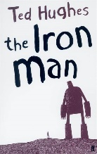  Focus domains:  Summarise  Language for effect  The Stone Age: Hunters, gathers and woolly mammoths.  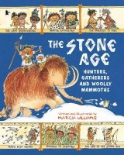  Focus domains:  Themes and conventions |  | Into the woods  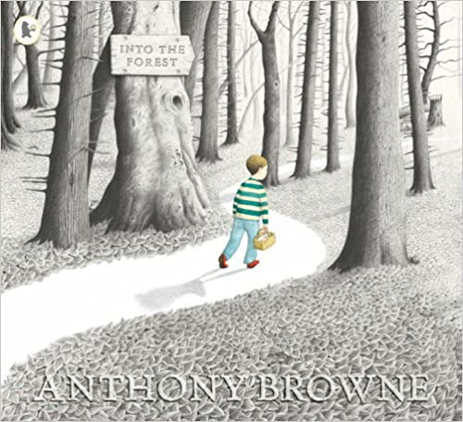  Focus domains:  Clarify  Respond and explain  Focus text:  Charlie changes into a chicken    Focus domains:  Select and retrieve  Inference |  | The Tin forest  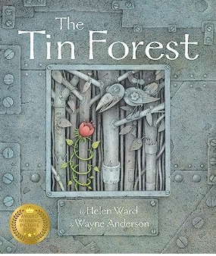  Focus domains:  Summarise  Respond and Explain  Focus text:  The magic far away tree    Focus domains:  Inference  Respond and explain  Poem- I am the seed that grew the tree  Language for effect |  | The Giraffe, Pelly and me  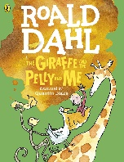  Focus domains:  summarise  Focus text:  Poem -The sound collector  Focus domains:  Language for effect  (visualise) |  | So you think you’ve got it bad: Ancient Rome  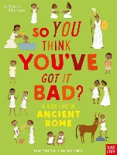  Focus domains:  Respond and explain  Themes and conventions  Romans on the rampage  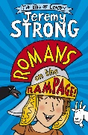  Focus domains:  Clarify  Summarise |  | Misadventures of Frederick  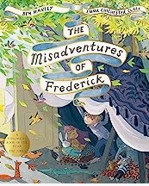  Focus domains:  Themes and conventions  Select and retrieve  The sheep-pig    Focus domains:  Inference
Science  ( see LTP when to cover) | Magnets Animals, skeletons and movement solids, liquids and gases Plants and their food Light rocks and soils  6 sessions 6 sessions 7 sessions production 7 sessions 6 sessions 4 sessions
Geography |  |  | WATERLOOVILLE  What’s special about our local area? |  | The Uk  Locational knowledge Human and physical  What is the UK like?  Where are the human and physical features in the UK? |  |  |  | European study  A place in Italy- Food  Is Campania a world away from our local area? |  | Zoos- animals that live in different continents  Compare different views about an ‘issue’  Will you find the same animals in each continent?
History | How did life change between The Neolithic (Stone), Bronze and Iron Ages? |  |  |  |  |  | The Roman Empire and its impact on Britain  What was the Roman Empire’s most significant impact? (on Britain)
RE  Living Difference | Message  Jesus’ teachings and message |  | Angels  Angels |  | Good & Evil  Holi |  | Symbol  The Cross |  | Sacred Place  Places of Worship  (Christianity & Hinduism) |  | Protection  Raksha  Bandhan
PE  Indoors | Gymnastics: pathways |  | Dance |  | Swimming |  | Fitness: gross motor/ circuit |  | Dance |  | Gymnastics; stretching, curling, arching
PE  Outdoors/ coach | Ball Skills  Games coach |  | Invasion games: Hockey  Games coach |  | Invasion games: Football |  | Net and Wall Games: Tennis  Games coach |  | Striking and fielding Games: Cricket  Games coach |  | Multi-Skills and Athletics
Art  Overview | Lascaux Cave  Drawing painting sculpture |  | David Hockney  Drawing painting collage |  | Cath Kidston  Drawing painting printing |  | Sarah Graham  Drawing painting photography |  | Paul Siggins  Drawing painting sculpture |  | Anthony Browne  Drawing painting sculpture
Computing  Teach Computing | Connecting computers |  | Stop-frame animation |  | Sequencing sounds |  | Branching databases |  | Desktop publishing |  | Events and actions in programs
DT  Kapow | Food: Seasonally |  |  |  | Structures: Constructing a castle |  |  |  | Digital World: Electronic charms
Music  Hampshire music service | Dimensions Focus: duration & structure |  | Dimensions Focus: pitch & duration |  | Dimensions Focus: pitch & texture |  | Dimensions Focus: texture & timbre |  | Dimensions Focus: pitch & structure |  | Dimensions Focus: duration, dynamics & tempo
PSHE / RSE  overview | Respect |  | Self-Regulation |  | Focus |  | Boundaries |  | Independence |  | Resilience
MFL  French  Kapow |  | French greetings with puppets |  | French adjectives of colour, size and shape |  | French playground games- numbers and age |  | In a French classroom | French transport | A circle of life in French

