Curriculum overview 2023 24 | Autumn 1 | Autumn 2 | Spring 1 | Spring 2 | Summer 1 | Summer 2
Year 2 | On Safari  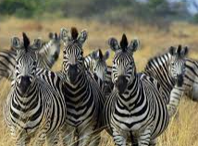 | Great Fire of London  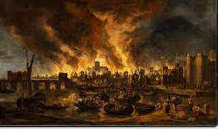 | Fractured Fairy Tales  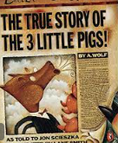 | Magic and potions  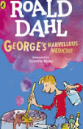 | Minibeasts  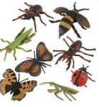 | In the footsteps of Kings  Porchester castle  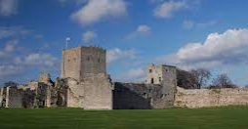
TRIPS | Marwell | Fire brigade visit to school  Farm visit | Library | Magician to school |  | Porchester castle
English  Writing journey | Text Driver:  ‘Giraffes can’t dance’ – Giles Andreae  Meerkat Mail-  Emily Gravett | Text Driver:  ‘Vlad’ – Kate Cunningham | Text Driver:  Original story: 3 little pigs  ‘The true story of the 3 little pigs’ – Jon Scieszka | Text Driver:  ‘George’s marvellous medicine’ – Roald Dahl | Text Driver:  ‘The bugliest bug’ – Carol Diggory Shields  The bee Book  Charlotte Milner | Text Driver:  ‘Queen Victoria’s bathing machine’ – Gloria Whelan  Where the wild things are  Maurice Sendak
Reading | 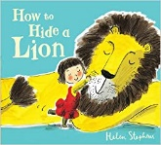  Focus domains:  Clarify  Meerkat Mail  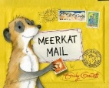  Focus domains:  Select and retrieve  Summarise | Toby and the Great Fire of London  Focus domains:  Respond and explain  Focus text:  Tortoise V Hare  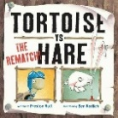  Focus domains:  Summarise  Themes and conventions | Little Red and the very hungry lion  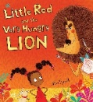  Focus domains:  Select and retrieve  Respond and explain  Focus text:  Who’s afraid of the big bad book?  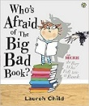  Focus domains:  Themes and conventions | Leon and the place between  Focus domains:  Select and retrieve  Summarise  Focus text:  Fantastic Mr Fox  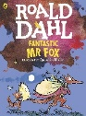  Focus domains:  Language for effect  Respond and explain | Non- Fiction Minibeasts  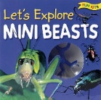  Focus domains:  Select and retrieve  Focus text:  Superworm  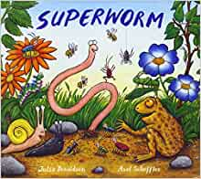  Focus domains:  Clarify  Inference  Poem- The owl who was afraid of the Pussy cat  Summarise  Language for effect | Focus texts:  Non- Fiction Victorians  Focus domains:  Select and retrieve  Themes and conventions  Focus text:  The lighthouse keepers lunch  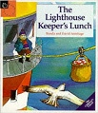  Focus domains:  Clarify  Respond and explain
Science  (See LTP for when to cover) | Animals lifecycles Changing materials Pushes and pulls Making new plants 7sessions 12 sessions 8 sessions 8 sessions
Geography | On Safari- Kenya  Where do zebras live?  Geographical Questions |  | London  The UK- 4 countries  What is special about The United Kingdom? |  | Weather and seasons  My local park is perfect all year round  Fieldwork
History |  | Remembrance Day  Great Fire of London  Why did the Great fire of London cause so much damage and what happened as a result? |  | Medicines – Mary Seacole/ Florence Nightingale  Who is more significant, Mary Seacole or Florence Nightingale?
RE  Living Differnce | Persuasion  Why did people follow Jesus? | Light as Symbol  Advent & Hannukah | Authority  Key Events in Jesus’ Life | Welcoming  Palm Sunday | Authority  The Bible | Remembering  Shabbat
PE  Indoor | Gymnastics  Parts high and parts low | Multi skills | Dance | Net and wall Games: Mini Tennis | Dance | Gymnastics:  Spinning, turning, twisting
PE  Outdoor/ coach | Ball skills  Games coach | Invasion Games/Ball Skills: Netball | Net and wall Games: Tennis  Games coach | Invasion / ball skills: basketball  Games coach | Striking and fielding Games: Rounders | Multi-Skills and Athletics  Games coach
Art  Overview | David Shepherd  Invite David Shepherd Foundation in  Drawing  Pianting  Printing | Sam Cunningham  Invite Sam Cunningham in  Drawing  Pianting  Collage | Jennie Maizels  Drawing  Pianting  Collage | Quentin Blake  Drawing  Pianting  Sculpture | Leonardo da Vinci  Drawing  Pianting  Card sculpture | Paul Klee  Drawing  Pianting  Clay
Computing  Teach computing | IT around us | Digital photography | Robot algorithms | Pictograms | Making music | Programming quizzes
DT  Kapow | Mechanisms: Making a moving monster |  | Structures: Baby Bear’s chair | Food: A balanced diet | Mechanisms: Fairground wheel | Textiles: Pouches
Music | Dynamics and tempo | Pitch and duration | Timbre and texture | Pitch | duration | Structure and timbre
PSHE / P4C  Overview | Respect | Self-Regulation | Focus | Boundaries | Independence | Resilience

