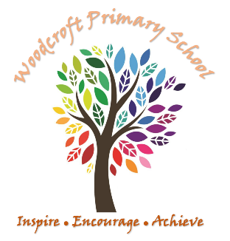

Woodcroft Primary School Curriculum Vision
At Woodcroft Primary school, we have designed an ambitious curriculum that provides our pupils with the skills and knowledge to successfully achieve in an ever-changing world. We encourage them to explore and widen their own interests, generating curiosity through delivering a broad and balanced child-focused curriculum. Woodcroft Primary School inspires its pupils through real-life experiences and raises expectations on what individuals are able to accomplish.

Curriculum Intent
At Woodcroft Primary school, subjects are taught through overarching and varied topics designed to inspire children’s interests and develop their understanding of the world around them. Unique experiences engage pupils and provide real life context where skills and knowledge can be applied. These are linked and progress each year, encouraging pupils to build on previous learning. Practical, fun and active lessons, help children create memorable ideas that they retain in the long term and that they can apply to different situations.

Core Values
Our Core School Values help embed the curriculum and support a culture of Learning for a lifetime.
Respect: Pupils are respectful of others and themselves regardless of differences. Demonstrating this even when in the most challenging situations.
Boundaries: Pupils challenge their own boundaries to achieve, understanding that other people have different boundaries that they respect.
Independence: Pupils are independently curious about their learning and the world around them; they can demonstrate initiative in learning and life.
Resilience: Pupils seek challenge and choose options that offer personal growth and development understanding that achievements require effort and perseverance.
Focus: Pupils can demonstrate focus when learning, through their actions they support and encourage others to focus on tasks presented to them.
Self-regulation: Pupils are able to self–regulate their feelings in order to maximise their ability to manage different situations that will occur in their lives.

Woodcroft Teaching Pedagogy
- Child-led discussion
- Clear progressive learning journeys
- ‘Live’ feedback through thoughtful AFL
- Modelling that deepens language and broadens vocabulary
- Challenge and support for all
- Targeted inputs and flexible groupings
- Every child taught by the teacher in every lesson
- Opportunities for children to work in different ways
- High expectations for each individual
- Questioning that extends and challenges
- Prior learning is revisited and reviewed which allows for new learning to build on previous skills and knowledge.

